Four Corners Periodontics, P.C.

Mark S. Blue, DDS
Practice Limited to Periodontics,

Including Dental Implants
MUTUAL COMMITMENTS TO FINANCIAL AND APPOINTMENT ISSUES
We feel that mutual commitments by you and our practice to financial and time-management issues are important in achieving our goal of establishing long-lasting, meaningful relationships with the people that seek us for treatment. Breaking financial and time agreements between people demonstrates lack of respect by the guilty party and violates important principles that exist to ensure success in any endeavor.

COMMITMENT TO TIME ARRANGEMENTS
In order to try to meet the scheduling requests of all of our patients, we have established some guidelines for reserving appointment times. Your appointment time is reserved only for you, as we treat only one patient at a time. Many patients need our services and missed appointments affect everyone. Because we appreciate your time, we agree to be diligent in seeing you at your reserved time. So that we may provide care for all of our patients, we request that you give us 48 hours notice to change your reserved appointment time. We reserve the right to charge a 50$ fee for appointments that are broken without 48 hours prior notice. Please be on time for your appointment. If you are 15 or more minutes late, we reserve the right to reschedule your appointment.

COMMITMENT TO FINANCIAL ARRANGEMENTS
Payment in full is required at the time services are rendered. We accept Cash, Check, Visa, Master Card, Discover and American Express. We also have a dental finance plan called Care Credit available. Due to the exceptional nature of periodontal disease and the specialized nature of some of its necessary treatments, some dental insurance companies unfortunately do not cover some of the procedures.
We are providers for Delta Dental only. If you have this plan, you will only be required to pay your anticipated portion at the time the service is rendered. We will file your insurance claim for you. After the insurance company pays the benefit, you will be responsible for any remaining balance.
For all other dental insurance plans, as a courtesy to you, we will file your claim and submit any information they may need to assist you in collecting your individual insurance assignments. Your dental carrier will then send all estimates or payments directly to you. Your dental insurance exists as a private agreement between you and your dental insurance company to assist you with some of your dental expenses.
While we will be diligent in assisting you in interpreting your potential insurance benefits, our treatment recommendations will be made solely on sound science and physiological principles and not with individual insurance recommendations in mind. We feel that treating patients otherwise violates our mission of providing our patients the highest standard of care. In return for our commitment to treating you, we expect a similar commitment in your timely payment for services rendered. In the event that our contracted collection agency must be involved with account, you will be held responsible for not only the balance with us, but also the charges from the collection agency.

_________________ ________________________________ __________
Patient Name Patient Signature or (Guardian) Date

Patient Information
Chief Complaint (Reason for Visit)________________________________________________
Who Referred You to Our Office:________________________________________________

Patient’s Name ________________________________________________________________
(Last) (First) (Middle Initial)

Address ______________________________________________________________________
(Street and Number) (City) (State & Zip)

Phone Numbers ( ) ____________________ ( ) _______________ ( ) _____________
(Home) (Work) (Cell)

Social Security Number: _______________________ Date of Birth: _________________

Email Address ___________________________Contact Preference:  Call  Text  Email

Sex: Female Male Marital Status:  Married  Single Occupation:____________________
Parent/Guardian Emergency/ Spouse Information

Parent/Guardian/Emergency/Spouse ______________________________________________
(Last) (First)
Address ______________________________________________________________________
(Street and Number) (City) (State & Zip)

Phone Number ( ) ________________
Insurance Information

Do you have Dental Insurance:  No  Yes

Primary Subscriber: __________________Date of Birth__________Member ID #_____________

Insured’s Employer:____________________________Group Number:__________________

Insurance Company: _________________________ Phone Number ( ) _______________

Claims Address:____________________________________________________________

Dental History
Previous Periodontal Therapy?  yes.  no
Fear of Dental Treatment  yes.  no
Type of Periodontal Therapy __________________________________________________________________________________________________________________________________________________________________________
Date of Therapy________________

ACKNOWLEDGEMENT OF RECEIPT OF
NOTICE OF PRIVACY PRACTICES
**You May Refuse to Sign This Acknowledgement**
I, , have received a copy of this office’s Notice of
Privacy Practices.
{Please Print Name}
{Signature}
{Date}
For Office Use Only
We attempted to obtain written acknowledgement of receipt of our Notice of Privacy Practices, but acknowledgement could not be obtained because:
- Individual refused to sign
- Communications barriers prohibited obtaining the acknowledgement
- An emergency situation prevented us from obtaining acknowledgement
- Other (Please Specify)

© 2002 American Dental Association
All Rights Reserved
Reproduction and use of this form by dentists and their staff is permitted. Any other use, duplication or distribution of this form by any other party requires the prior written approval of the American Dental Association.
This Form is educational only, does not constitute legal advice, and covers only federal, not state, law (August 14, 2002).

Medical History

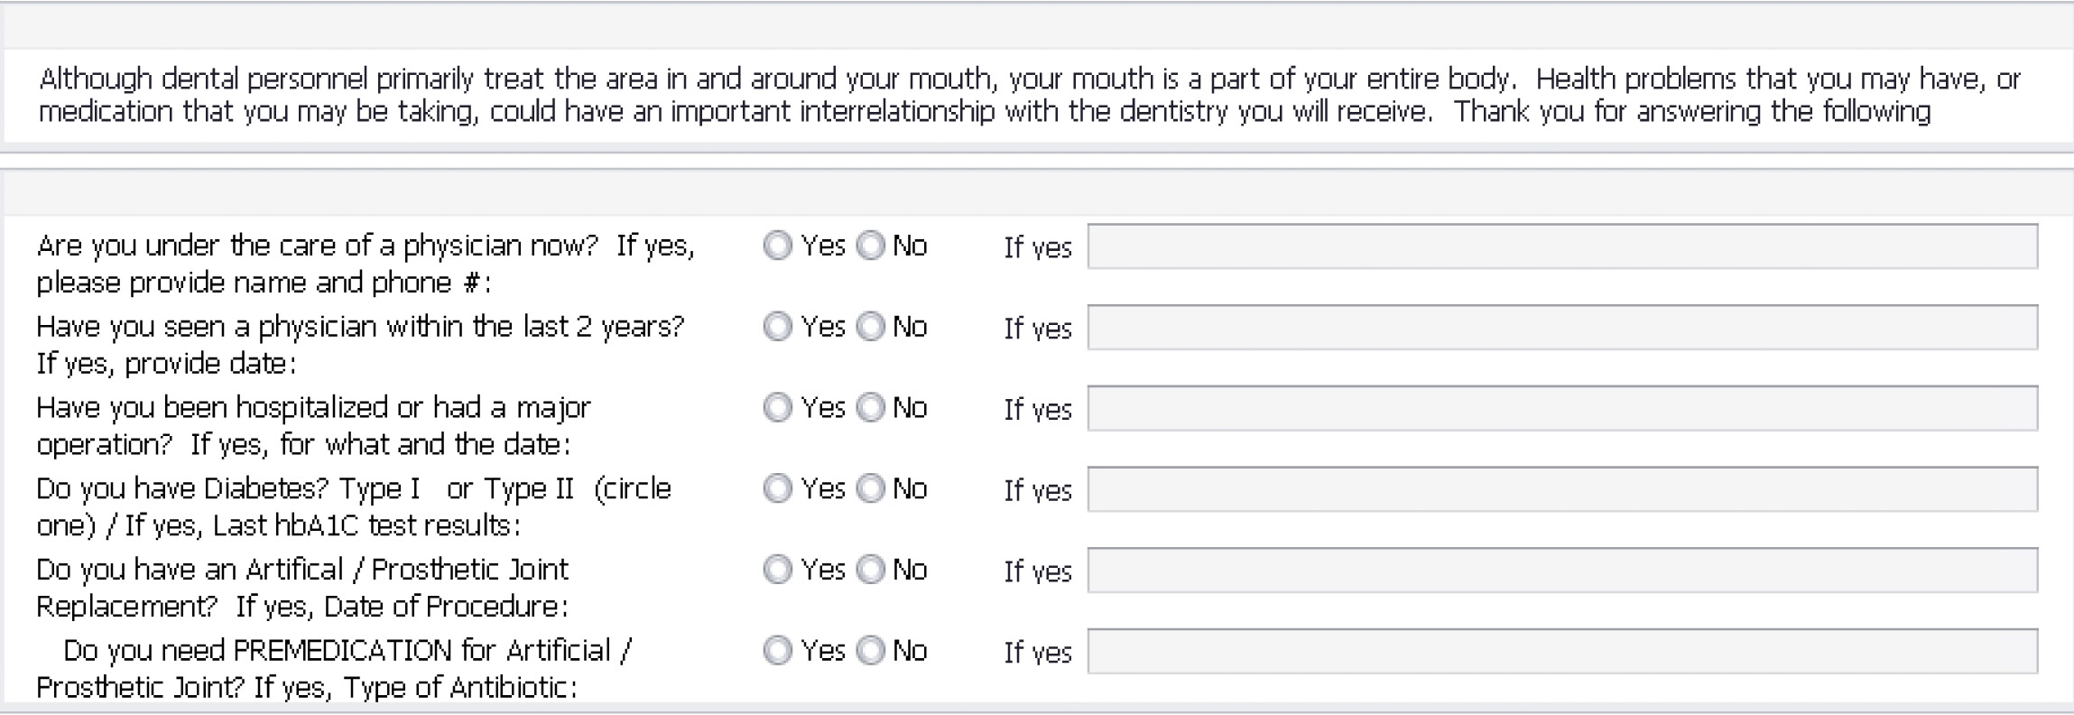

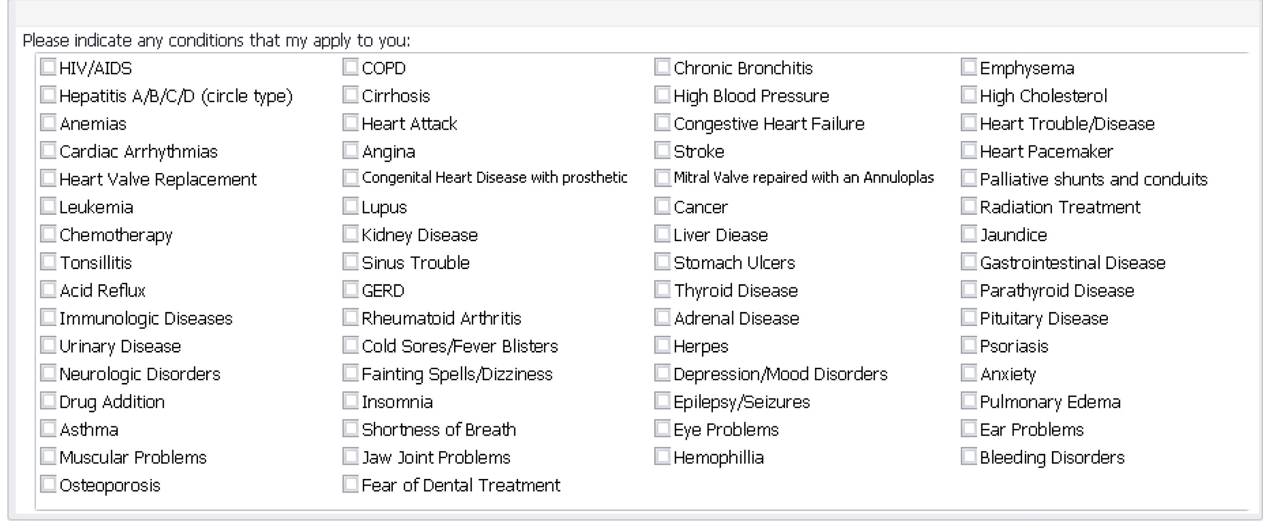

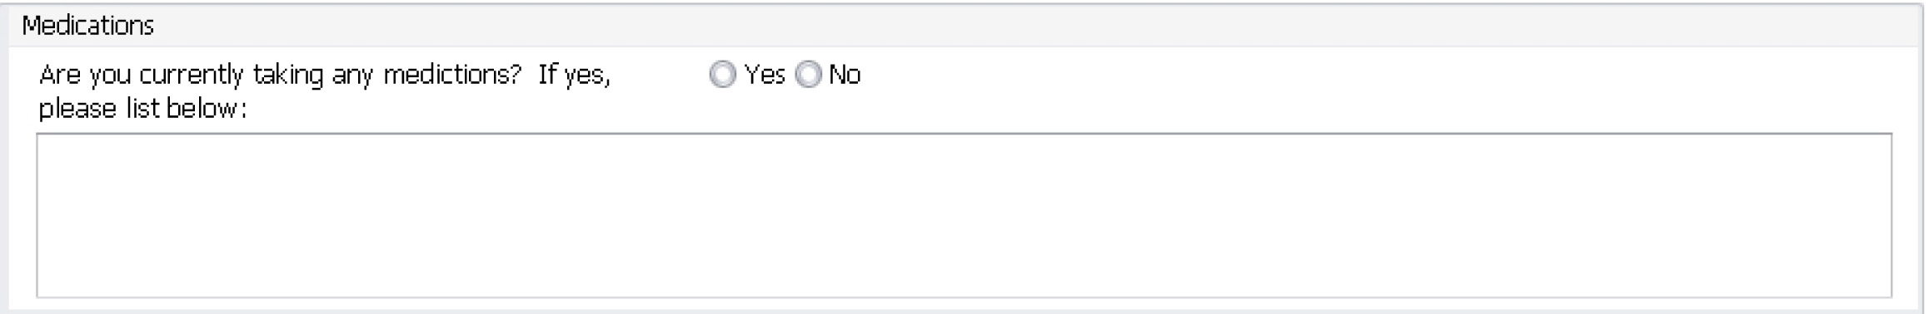

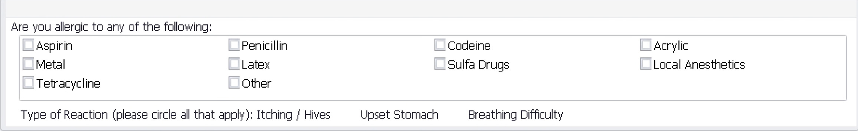
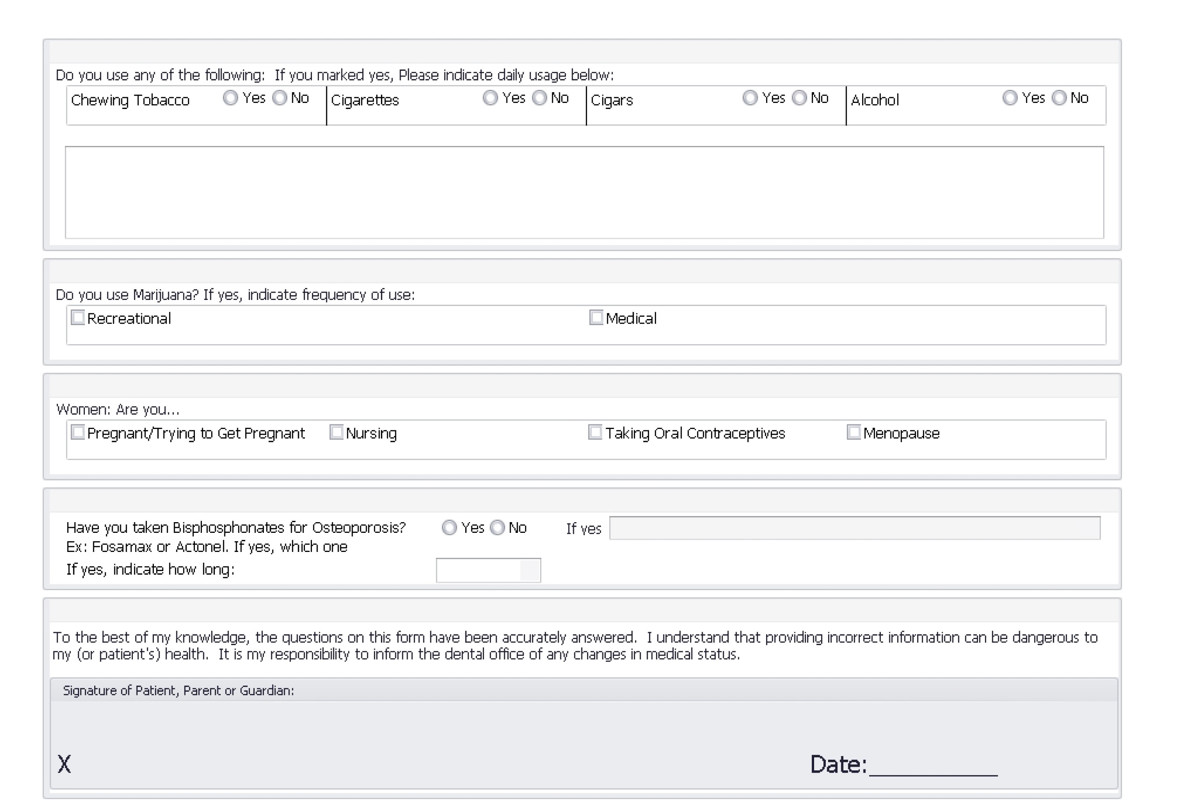

Sleep Disorder Questionnaire
Indicate if you have the following symptoms and how frequently they occur
Rarely or never ( 0 ) Frequently ( 2 )
Some of the time ( 1 ) Often or most of the time ( 3 )
- I am sleepy during the day though I have slept through the night ______
- I fall asleep when watching TV even though I try to stay awake ______
- I have fallen asleep during routine situations ______
- I have been told that I snore loudly even when sleeping on my side ______
- I have been told that I stop “breathing” at night ______
- I wake up at night and cannot go back to sleep no matter how hard I try ______
- I have been told that I grind or clench my teeth when sleeping ______
Consent for Treatment
To the best of my knowledge the information enclosed is complete and correct. I hereby give permission for dental treatment to be accomplished and for photographic recordings of the conditions and treatment for the advancement of Dental Science.

Signature (patient,parent or guardian) Date


